1. Redhat enterprise linux 7 installed
2. Users created from orguser01 – orguser25 with password from orguser01 – orguser25

& directories home/user01 - /home/user25

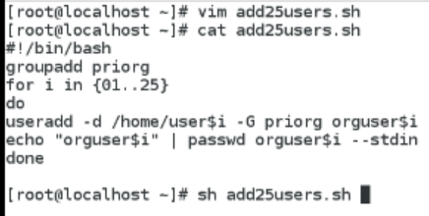

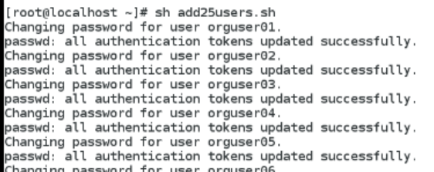

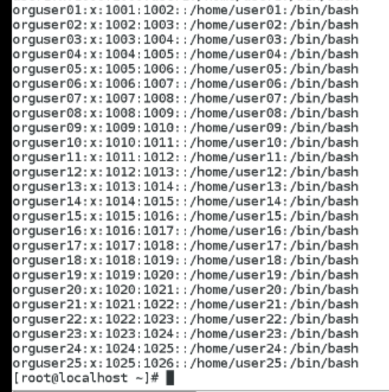

1. Added user to group “priorg”

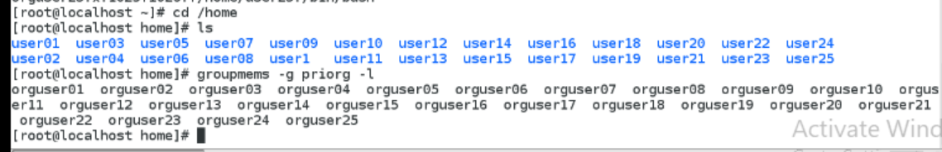

1. Network congiguration

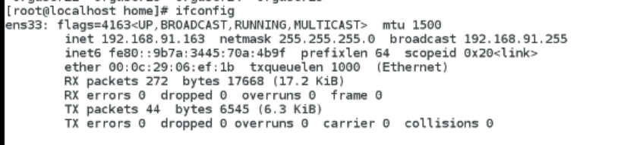

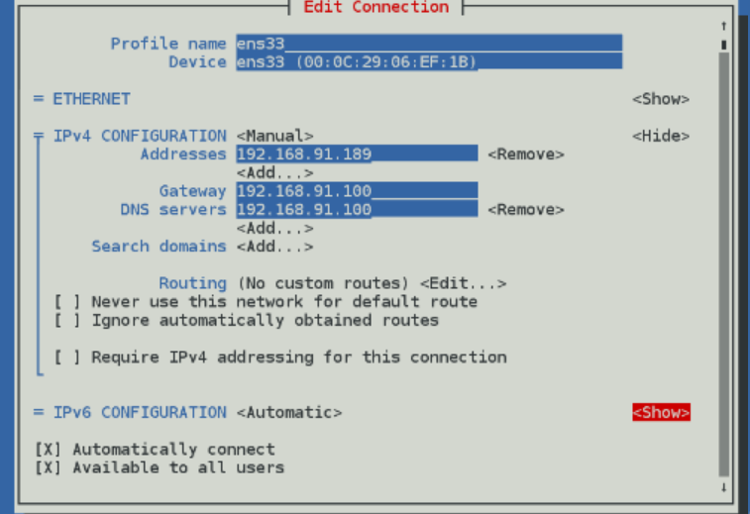

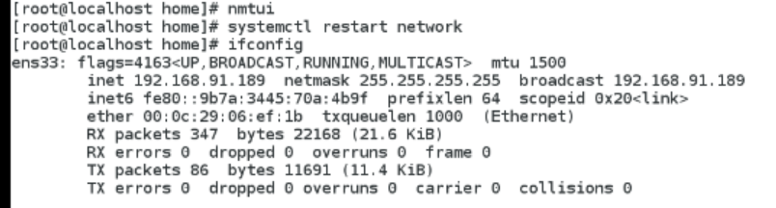

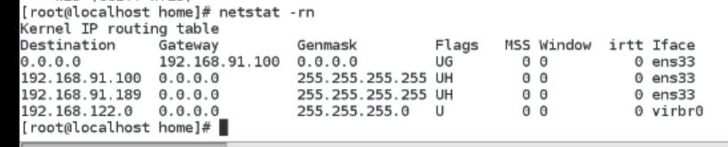

1. Setting host name

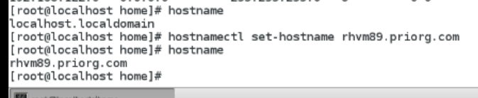

1. Ssh has to be enabled for al user and disabled for root

Restrict the permitrootlogin 🡺 no

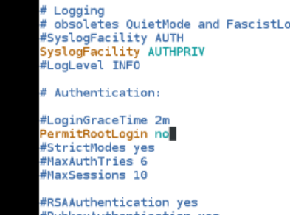

1. Creating daily backup of /home directory using crontab & savin file name as org-home _ddmmyy.tar.gz in /etc/orgbackups

